SOFTWARE REQUIREMENT SPECIFICATION
Smart Museum Visitor Experience and Artifact Monitoring Platform
A Scenario-Based Requirement Analysis Document

1. Introduction

1.1 Purpose
This Software Requirement Specification (SRS) document describes the functional and non-functional requirements for the Smart Museum Visitor Experience and Artifact Monitoring Platform. The purpose of this document is to provide a clear, complete, and unambiguous description of the system to be developed, so that it can be used as a reference by project stakeholders, system designers, developers, and testers throughout the software development lifecycle.

1.2 Document Conventions
Requirements are identified using unique identifiers: FR-xx for Functional Requirements and NFR-xx for Non-Functional Requirements. The keywords "shall" and "must" indicate mandatory requirements, while "should" indicates a desirable but non-mandatory requirement.

1.3 Intended Audience
- Museum management and curatorial staff
- Software architects, designers, and developers
- Quality assurance and testing teams
- IoT and AR solution integrators
- Museum security personnel and IT administrators
- Academic evaluators reviewing the requirement analysis

1.4 Business Domain
The system operates within the cultural heritage and museum management domain, specifically at the intersection of visitor experience technology and artifact conservation science. It leverages Internet of Things (IoT) sensing, Artificial Intelligence (AI) recommendation systems, Augmented Reality (AR) content delivery, RFID-based tracking, and cloud computing to modernize museum operations while safeguarding irreplaceable cultural assets.

1.5 References
- IEEE Std 830-1998, IEEE Recommended Practice for Software Requirement Specifications
- ICOM (International Council of Museums) guidelines on environmental standards for artifact preservation
- Assigned Problem Statement: "Smart Museum Visitor Experience and Artifact Monitoring Platform"

2. Problem Description
Museums today face a dual challenge: they must deliver engaging, personalized, and technologically enriched experiences to increasingly digital-native visitors, while simultaneously protecting fragile and often irreplaceable artifacts from environmental degradation, theft, and physical damage. Conventional museum systems rely on static placards, manual security patrols, and periodic (rather than continuous) environmental checks, which results in several unresolved problems:
- Environmental conditions such as temperature, humidity, and light exposure are checked manually and infrequently, increasing the risk of undetected artifact degradation.
- Visitors receive generic, one-size-fits-all tour information rather than recommendations tailored to their interests, available time, or accessibility needs.
- Interactive and immersive learning technologies such as Augmented Reality are largely absent, limiting engagement, especially among younger audiences.
- Security monitoring is largely reactive, relying on human patrols and CCTV review after an incident rather than real-time, sensor-driven alerts.
- Museum management lacks data-driven insight into visitor movement, dwell time, and preferences, making it difficult to optimize exhibition layouts or staffing.
- There is no centralized platform correlating visitor analytics, artifact condition data, and security events for holistic, informed decision-making.
The proposed Smart Museum Platform addresses these gaps by integrating IoT-based environmental and security monitoring, AI-driven personalization, AR-based interactive exhibits, and visitor-behavior analytics into a single, cloud-connected system.

3. Scope of the System
The Smart Museum Visitor Experience and Artifact Monitoring Platform is a cloud-connected software system, supported by an IoT sensor network and mobile/AR-enabled visitor applications, that will:
- Continuously monitor artifact environmental conditions (temperature, humidity, light, vibration) and physical security status using IoT sensors and RFID tags.
- Generate real-time alerts to curatorial and security staff when readings breach preservation thresholds or when unauthorized artifact movement is detected.
- Provide visitors with a mobile application offering AI-generated personalized tour recommendations based on stated interests, available time, and past visit history.
- Deliver AR-based interactive content (3D models, historical reconstructions, multilingual narration) when visitors scan or approach exhibits.
- Track anonymized visitor movement and dwell time within gallery zones using indoor positioning/RFID/Bluetooth beacons to analyze engagement patterns.
- Provide museum management with analytics dashboards covering visitor flow, exhibit popularity, artifact condition history, and security incident logs.
- Support ticketing, payment, and feedback collection integrated with the visitor mobile experience.
Out of Scope: The system does not include physical construction of display cases, procurement of artifacts, or replacement of the museum's core financial/accounting ERP system. Integration with such external systems is limited to defined interfaces described in Section 9.

4. Stakeholder Analysis
Stakeholder | Role / Interest | Key Concerns
Museum Visitors | End users of the mobile app and AR exhibits | Ease of use, personalization, engaging content, ticketing convenience
Curators / Collection Managers | Responsible for artifact care and exhibit content | Accurate condition monitoring, timely alerts, exhibit management tools
Security Personnel | Physical protection of artifacts and visitors | Real-time intrusion/tamper alerts, incident response tools
Museum Management / Directors | Strategic decision-making and budgeting | Analytics on visitor satisfaction, ROI, operational efficiency
IT / System Administrators | System deployment, configuration, uptime | Reliable infrastructure, easy sensor/user management, security
Conservation Scientists | Long-term artifact preservation research | Historical environmental data, trend analysis, reporting accuracy
Third-Party Vendors | IoT hardware, AR content, payment gateway providers | Well-defined APIs and integration interfaces

5. Functional Requirements
Functional requirements are grouped by subsystem for clarity.

5.1 Visitor Engagement Module
ID | Requirement Description
FR-01 | The system shall allow visitors to register, log in, and manage a personal profile including interests and accessibility preferences.
FR-02 | The system shall generate AI-based personalized tour recommendations using visitor interests, available time, and historical visit data.
FR-03 | The system shall allow visitors to book tickets and make payments through the mobile application.
FR-04 | The system shall provide indoor navigation guidance directing visitors to recommended exhibits.
FR-05 | The system shall allow visitors to scan an artifact/exhibit tag (QR/RFID/NFC) to trigger AR-based interactive content.
FR-06 | The system shall deliver AR content including 3D reconstructions, multilingual audio narration, and historical context.
FR-07 | The system shall allow visitors to submit feedback and ratings for exhibits and overall visit experience.

5.2 Artifact Monitoring Module
ID | Requirement Description
FR-08 | The system shall continuously collect temperature, humidity, light intensity, and vibration data from IoT sensors placed near artifacts.
FR-09 | The system shall compare sensor readings against predefined preservation thresholds configured per artifact type.
FR-10 | The system shall generate real-time alerts to curatorial staff when readings exceed safe thresholds.
FR-11 | The system shall maintain a historical log of environmental readings for each artifact for trend analysis and reporting.
FR-12 | The system shall allow curators to configure/update threshold values and sensor mappings for each artifact.

5.3 Security Monitoring Module
ID | Requirement Description
FR-13 | The system shall detect unauthorized artifact movement or removal using RFID/motion sensors and trigger an immediate alert.
FR-14 | The system shall provide security personnel with a real-time dashboard of sensor and access-control status across galleries.
FR-15 | The system shall log all security incidents with timestamp, location, and sensor data for later investigation.
FR-16 | The system shall support integration with CCTV/access-control systems to correlate alerts with camera footage.

5.4 Visitor Analytics & Exhibition Planning Module
ID | Requirement Description
FR-17 | The system shall track anonymized visitor movement and dwell time across gallery zones using beacon/RFID data.
FR-18 | The system shall analyze visitor behavior to identify popular exhibits, congestion points, and underutilized areas.
FR-19 | The system shall generate exhibition layout optimization suggestions based on visitor flow analytics.
FR-20 | The system shall generate periodic museum performance analytics reports (visitor count, satisfaction scores, artifact condition summaries).

5.5 Administration Module
ID | Requirement Description
FR-21 | The system shall allow administrators to create, update, and deactivate user accounts and role-based permissions.
FR-22 | The system shall allow administrators to add, configure, and monitor the health/connectivity of IoT sensor devices.
FR-23 | The system shall provide data backup and restore functionality for all system data.
FR-24 | The system shall maintain an audit trail of all administrative actions performed within the system.

6. Non-Functional Requirements
ID | Category | Requirement Description
NFR-01 | Performance | The system shall process and display IoT sensor alerts within 5 seconds of threshold breach detection.
NFR-02 | Performance | The mobile application shall render AR content within 3 seconds of a successful artifact scan under normal network conditions.
NFR-03 | Scalability | The platform shall support at least 10,000 concurrent visitor-app sessions and 5,000 concurrently connected IoT sensors without degradation.
NFR-04 | Availability | Core monitoring services shall maintain 99.5% uptime, excluding scheduled maintenance windows.
NFR-05 | Reliability | Environmental sensor data shall not be lost even during temporary network outages; edge devices shall buffer and resynchronize data upon reconnection.
NFR-06 | Security | All visitor personal data and payment transactions shall be encrypted in transit (TLS 1.2+) and at rest (AES-256).
NFR-07 | Security | The system shall enforce role-based access control (RBAC) distinguishing visitor, curator, security, and administrator privileges.
NFR-08 | Usability | The visitor mobile application shall be usable by first-time users without training, following WCAG 2.1 AA accessibility guidelines.
NFR-09 | Maintainability | The system shall use a modular microservice architecture allowing independent updates to AI, AR, and monitoring modules.
NFR-10 | Interoperability | The system shall expose RESTful APIs to integrate with third-party ticketing, payment, and CCTV systems.
NFR-11 | Data Retention | Historical environmental and analytics data shall be retained for a minimum of 5 years to support long-term conservation research.
NFR-12 | Portability | The visitor application shall function on both Android and iOS platforms with consistent feature parity.

7. Actors and Use Cases

7.1 Primary Actors
- Visitor — interacts with the mobile app, AR content, ticketing, and feedback features.
- Museum Curator / Staff — monitors artifact conditions, manages exhibits, reviews analytics.
- Security Personnel — monitors security alerts and responds to incidents.
- System Administrator — manages users, sensors, backups, and overall system configuration.

7.2 Secondary Actors
- IoT Sensor Network — supplies environmental and motion data to the system.
- AR/AI Engine — supplies personalized recommendations and renders AR content.
- Cloud Analytics Service — processes large-scale visitor and artifact data for reporting.
- Payment Gateway — processes visitor ticket payments securely.

7.3 Use Case Diagram
The following use case diagram illustrates the interactions between the identified actors and the major use cases supported by the Smart Museum Platform.
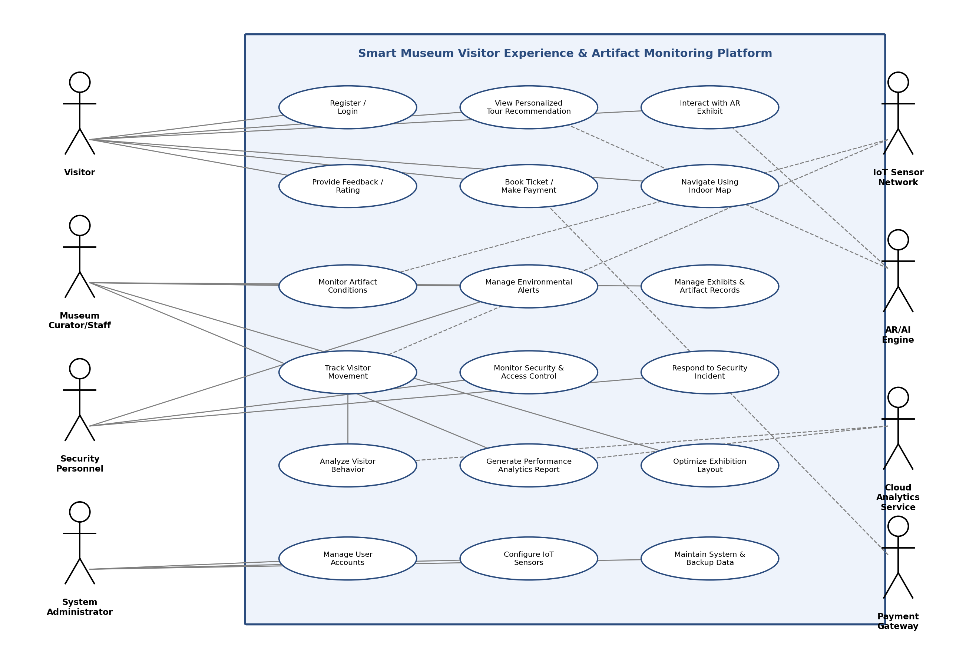
Figure 1: Use Case Diagram — Smart Museum Visitor Experience and Artifact Monitoring Platform

7.4 Use Case Descriptions

UC-01: View Personalized Tour Recommendation
Use Case ID | UC-01
Use Case Name | View Personalized Tour Recommendation
Primary Actor | Visitor
Preconditions | Visitor is registered/logged in.
Main Flow | 1) Visitor opens the app and selects 'Plan My Visit'. 2) Visitor specifies interests and available time. 3) AI Engine generates a ranked exhibit itinerary. 4) System displays the itinerary with navigation options.
Postconditions | A personalized tour itinerary is displayed and available for navigation guidance.

UC-02: Monitor Artifact Conditions
Use Case ID | UC-02
Use Case Name | Monitor Artifact Conditions
Primary Actor | Museum Curator/Staff
Preconditions | IoT sensors are installed and configured for the artifact.
Main Flow | 1) IoT sensors continuously transmit temperature/humidity/light data. 2) System compares readings against thresholds. 3) If a breach occurs, an alert is generated and sent to the curator. 4) Curator reviews the alert and takes corrective action.
Postconditions | Environmental readings are logged; alerts (if any) are recorded and acknowledged.

UC-03: Respond to Security Incident
Use Case ID | UC-03
Use Case Name | Respond to Security Incident
Primary Actor | Security Personnel
Preconditions | Security sensors and access-control integration are active.
Main Flow | 1) System detects unauthorized artifact movement or access breach. 2) System triggers an immediate alert to the security dashboard. 3) Security personnel view the incident location and relevant camera feed. 4) Personnel log response actions taken.
Postconditions | Incident is logged with timestamp, sensor data, and response notes.

UC-04: Generate Museum Performance Analytics Report
Use Case ID | UC-04
Use Case Name | Generate Museum Performance Analytics Report
Primary Actor | Museum Curator/Staff
Preconditions | Sufficient visitor and sensor data has been collected.
Main Flow | 1) Curator/Management selects the reporting period and metrics. 2) Cloud Analytics Service aggregates visitor flow, engagement, and artifact condition data. 3) System generates a formatted report/dashboard. 4) User exports or shares the report.
Postconditions | A performance analytics report is generated and made available for download/sharing.

8. Data Requirements
The system shall manage the following major data entities:
Data Entity | Description | Key Attributes
Visitor Profile | Registered visitor information and preferences | VisitorID, Name, Interests, Language, VisitHistory
Artifact Record | Master data for each artifact/exhibit | ArtifactID, Name, Category, Location, PreservationThresholds
Sensor Reading | Time-series environmental data per sensor | SensorID, ArtifactID, Timestamp, Temperature, Humidity, Light
Alert / Incident Log | Environmental and security alert records | AlertID, Type, Severity, Timestamp, Status, ResolvedBy
Tour Recommendation | AI-generated itinerary per visitor session | RecommendationID, VisitorID, ExhibitSequence, GeneratedOn
Visitor Movement Log | Anonymized zone-level movement and dwell time | SessionID, ZoneID, EntryTime, ExitTime
Ticket / Payment | Ticketing and payment transaction records | TicketID, VisitorID, Amount, PaymentStatus, Timestamp
Feedback / Rating | Visitor feedback on exhibits and overall experience | FeedbackID, VisitorID, ExhibitID, Rating, Comments
All personally identifiable visitor data shall be stored separately from anonymized analytics data, and access shall be governed by role-based permissions in compliance with applicable data protection regulations.

9. External Interface Requirements

9.1 User Interfaces
- Visitor Mobile Application (Android/iOS) — tour recommendations, AR viewer, ticketing, indoor navigation, feedback.
- Curator Web Dashboard — artifact condition monitoring, exhibit management, analytics reports.
- Security Dashboard — real-time alert map, incident logging, CCTV correlation view.
- Administrator Console — user management, sensor configuration, system health, backups.

9.2 Hardware Interfaces
- IoT environmental sensors (temperature, humidity, light, vibration) with wireless connectivity (Wi-Fi/LoRaWAN/Zigbee).
- RFID/NFC tags and readers for artifact identification and movement detection.
- Bluetooth Low Energy (BLE) beacons for indoor positioning and visitor movement tracking.

9.3 Software Interfaces
- RESTful APIs for integration with third-party ticketing and CRM systems.
- Payment Gateway API for secure transaction processing.
- Cloud storage and analytics platform APIs for data warehousing and reporting.
- AR content rendering SDK (e.g., ARKit/ARCore compatible) for mobile AR experiences.

9.4 Communication Interfaces
- HTTPS/TLS-secured communication between mobile app, dashboards, and backend services.
- MQTT protocol for lightweight, low-latency IoT sensor data transmission.

10. System Features

10.1 AI-Powered Personalization Engine
Recommends tours and exhibits based on visitor interest profiles, available time, and crowd-density data, dynamically re-ranking suggestions as visitors move through the museum.

10.2 IoT-Based Environmental & Security Monitoring
Continuously monitors artifact-critical environmental parameters and physical security status, generating real-time, prioritized alerts to relevant staff.

10.3 Augmented Reality Interactive Exhibits
Delivers immersive AR overlays — 3D reconstructions, historical simulations, and multilingual narration — triggered by artifact scanning or proximity detection.

10.4 Visitor Behavior Analytics & Exhibition Optimization
Analyzes anonymized movement and engagement data to identify congestion, popular exhibits, and underused spaces, informing data-driven layout decisions.

10.5 Integrated Ticketing and Feedback
Provides seamless in-app ticket booking, payment, and post-visit feedback collection to close the visitor engagement loop.

11. Assumptions and Constraints

11.1 Assumptions
- Visitors carry smartphones capable of running the AR-enabled mobile application.
- The museum premises have adequate Wi-Fi/network coverage to support IoT connectivity and real-time app usage.
- Curatorial staff will define and periodically review environmental thresholds for each artifact category.
- Museum management will provide access to historical visitor and ticketing data for initial AI model training.
- Sensor hardware vendors will provide stable APIs/SDKs for integration.

11.2 Constraints
Type | Constraint Description
Technical | IoT sensors must operate within the museum's existing electrical and network infrastructure without invasive structural modification to heritage buildings.
Operational | System deployment and sensor installation must occur during non-visiting hours to avoid disrupting museum operations.
Economic | The project budget limits the number of high-precision sensors deployable in the initial phase; a phased rollout is required.
Legal / Regulatory | The system must comply with data protection regulations (e.g., GDPR-equivalent) for visitor personal data, and heritage conservation guidelines for artifact handling.
Time | The system must be deployed and operational in time for the museum's seasonal peak visitor period.
Environmental | Sensor placement must not alter the aesthetic presentation of exhibits or interfere with conservation display cases.

12. Validation of Requirement Completeness and Consistency

12.1 Stakeholder Coverage Check
Each identified stakeholder group has at least one corresponding functional requirement and use case: Visitors (FR-01 to FR-07, UC-01), Curators (FR-08 to FR-12, FR-19 to FR-20, UC-02, UC-04), Security Personnel (FR-13 to FR-16, UC-03), and Administrators (FR-21 to FR-24). This confirms that no primary stakeholder group has been left unaddressed.

12.2 Ambiguity, Redundancy, and Inconsistency Review
- Ambiguity: Vague terms such as "fast" or "user-friendly" have been avoided in favor of measurable criteria (e.g., NFR-01 specifies a 5-second alert threshold; NFR-08 references WCAG 2.1 AA).
- Redundancy: Requirements were cross-checked to ensure alert-generation logic (FR-10, FR-13) is defined once per module rather than duplicated across sections.
- Inconsistency: Terminology has been standardized — "artifact" is used consistently rather than interchanging with "exhibit" or "item" where a specific object is meant.
- Traceability: Each functional requirement maps to at least one use case and one stakeholder need, enabling forward traceability into design and test cases.

12.3 Identified Gaps and Recommended Improvements
- Add explicit disaster-recovery and failover requirements for the cloud analytics service to strengthen NFR-04 (Availability).
- Define specific data retention and anonymization schedules for visitor movement data to strengthen legal compliance (Section 11.2).
- Introduce a requirement for offline AR content caching to handle areas with weak indoor connectivity.
- Add multilingual support requirements explicitly to the Non-Functional Requirements (currently only referenced under System Features).
- Conduct a formal stakeholder review workshop to validate threshold values (FR-09) with conservation science experts before implementation.

12.4 Conclusion
This SRS document establishes a validated, traceable, and testable set of requirements for the Smart Museum Visitor Experience and Artifact Monitoring Platform. The requirements collectively address the objectives of environmental monitoring, personalized visitor engagement, AR-based interactivity, security enhancement, and data-driven museum management, while remaining consistent, unambiguous, and aligned with all identified stakeholder needs.

